**SAS**

**Whitepaper**

**SAS BLOCK TECH LTD**

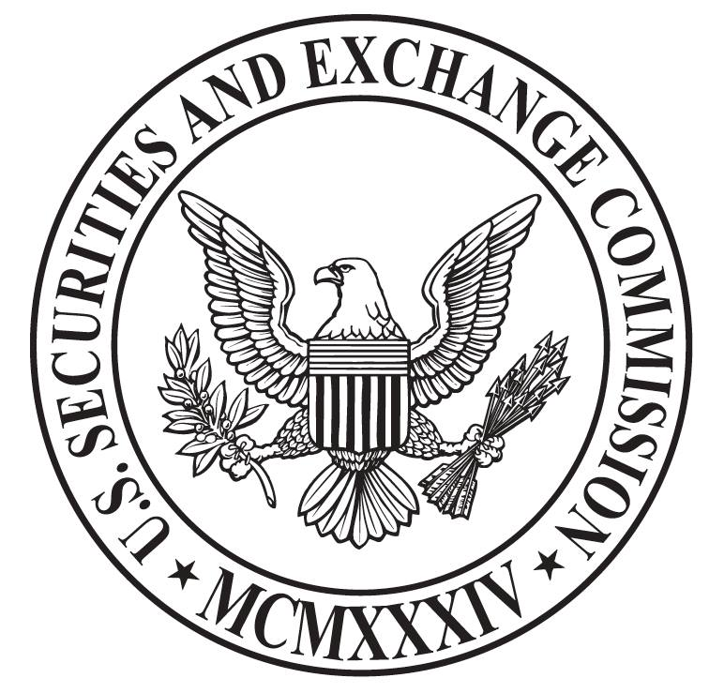

SAS BLOCK TECH LTD has applied to the SEC (US Securities Regulatory Commission) for registration.

CIK: 0001773898

Query the registration files: sec.gov→Filings→Edgar search tools→

[Company or fund name, ticker symbol, CIK (Central Index Key),file number, state, country, or SIC (Standard Industrial Classification)](https://www.sec.gov/edgar/searchedgar/companysearch.html)

→Fill in company name: SAS BLOCK TECH LTD

→Search

Or click this link to directly enter the filing file:

<https://www.sec.gov/Archives/edgar/data/1773898/000177389819000001/xslFormDX01/primary_doc.xml>

**SAS Whitepaper Statement**

The whitepaper will not constitute legal, financial, commercial or tax advice. You should consult with your own legal, financial, tax or other professional advisers before engaging in any activity related to the whitepaper. Whether it is SAS Block Tech Ltd. (hereinafter referred to as SAS Project Foundation), any project team member working on the SAS platform and for any related project, or any third-party service provider, they won’t be responsible for any direct or indirect damages or losses suffered by receiving the whitepaper, materials provided by the SAS Project Foundation or any other material published by the SAS Project Foundation partner.

All contributions will be used to fulfill the objective of the SAS Project Foundation, including but not limited to enhancing the user experience of the product, improving product systems and services, promoting community improvement and forward development, updating and improving open source SAS to facilitate the integral development of the industry, researching and developing with in-depth study and design of the blockchain market for commodity and service flow, transfer and transaction, exploring the product form of the transaction media terminal system and commodity trading market under next generation blockchain.

The whitepaper is for informational purpose only and does not constitute an offer of the prospectus, the agreements document and the securities offer or an offer to sell any product or asset. The information below may not be exhaustive, which can’t be treated as the element of contractual relationship. As to the accuracy and completeness of the information which are not assured, the whitepaper will not be intended to provide any representation, warranty or promise. In the event that the whitepaper contains information obtained from third-parties, the SAS Project Foundation and the SAS team do not independently verify the accuracy or completeness of such information.

The whitepaper does not constitute an offer by the SAS Project Foundation or the SAS team to sell any digital assets or virtual assets. The whole or any part thereof with facts stated do not form the basis of any contract or investment decision, which can’t be taken as the link to any contract or investment decision. Everything contained in the Whitepaper is not and can’t be cited as a commitment, statement or promise to the future performance of the Platform. Any agreement signed with the SAS Project Foundation or its affiliates to buy and sell SAS is controlled solely by the terms and conditions of the agreement.

In the whitepaper, there will not be any statement or warranty regarding to corporate finance no matter it is public or private, for specific investors or general investors. The SAS team insists on legal compliance. SAS Block Tech Ltd. will retain the prosecution right if you illegal use SAS, SAS Company Information (SAS Block Tech Ltd.), SAS shareholders, directors and actual controller information for public, private, compliance or non-compliance.

The SAS Project Foundation and the SAS team do not and will not make any statement, warranty or promise to any entity or individual, and declare no liability. Potential buyers of SAS ought to carefully consider and evaluate all risks and uncertainties associated with SAS sales, foundations and SAS teams including financial and legal risk uncertainties.

After reading all or any part of the whitepaper, you make representations and warranties to the SAS Project Foundation and the SAS team as follows.

You acknowledge, understand and agree that SAS may be of no value, that the SAS Project Foundation does not guarantee or state in regard to the value or liquidity of SAS and that SAS is not used for speculative investments;

You will not make the decision to purchase any SAS in accordance with any of the statements in the whitepaper or any form of information provided by third-party service providers of SAS projects;

You will stand the expense to ensure that you comply with all laws, regulatory requirements and restrictions that apply to you;

You acknowledge, understand and agree that if you are a citizen, resident or green card holder of the United States of America, a citizen or resident of the People's Republic of China, or live in the country that does not support digital monetary operation, you will not have the qualification for purchase or transaction of SAS.

The agreement to purchase and sell SAS shall be governed by the terms and conditions of the separate SAS purchase agreement (hereinafter referred to as SAS Purchase Agreement), which will be issued by the SAS Project Foundation prior to any sale of SAS. If there is any inconsistency between the SAS Purchase Agreement and the whitepaper, all should be subject to the SAS Purchase Agreement.

All statements, press releases and statements of public accessibility contained in the whitepaper, as well as any oral statements and informal written statements that are likely to be made by the SAS team, may constitute forward-looking statements including information about market conditions, business strategy and plans, financial status, specific regulations and statements of intentions, beliefs and current forecasts of risk management practices. It’s a sincere suggestion not to unduly or superstitiously rely on forward-looking statements as there are known and unknown risks, uncertainties and other factors that may cause actual results in future quite different from results described in the forward-looking statements. These forward-looking statements are only applicable in the whitepaper. In the meantime, the SAS Project Foundation and the SAS team make it clear that they disclaim any express or implied obligation to modify forward-looking statements to reflect events after this date.

Since SAS is an important participatory tool for the SAS platform with special access and lack of corresponding guarantee about the asset rights claim, possession and the asset value, we assess the SAS as a SAS platform product and characterize the sale process as SAS pre-sale and non-regulated forms of commodity crowdfunding.

The whitepaper may be translated into a language other than English. If there is a conflict or ambiguity between the English version of the whitepaper and its translated version, the English version should be taken as the criterion.

You acknowledge that you have read and understood the English version of the whitepaper. Any part of the whitepaper should not be copied, reproduced, distributed, or transmitted in any way without the prior written approval of the Foundation.

|  |  |  |
| --- | --- | --- |
|  |  | **Catalogue** |
| 1 | **Preface** |
| 2 | **Introduction to SAS Project** |
|  | Project introduction |
|  | Project Framework |
|  | Application Scenarios |
|  | SRT Protocol |
|  | Project Vision |
| 3 | **Technology**  BFT-DPOS Consensus Mechanism of SAS  Transaction Confirmation  Proof of Completion  Smart Contract System - SRT |
| 4 | **Development** |
| 5 | **Allocation** |
|  | Issuance of Allocation Plan |
| 6 | Usage  **Disclaimer**  What is SAS  Usage of SAS  Method of settlement  What can't SAS do  SAS is not a loan to the company  SAS is non-refundable |
| 7 | **Company Personnel** |
| 8 | **Compliance Program** |

**Preface**

The economic growth of mankind in the past 250 years is the result of three industrial revolutions.

The first industrial revolution lasted from the 1760s to 1840, marked by the invention of steam power, the mechanization of textile industry and the transformation of metallurgical industry. The Second Industrial Revolution began in the 1860s and lasted until the World War II, which marked by the invention and application of electric power and internal combustion engines, as well as the emergence of new industries such as petrochemical industry and household appliances. The third Industrial Revolution began in the 1950s and has lasted until now. Its symbol is the invention of computers, information technology and the transformation of the communications industry. These great changes have brought us prosperity and glory.

Now, we are in the frenzy of the fourth industrial revolution. The value Internet from the blockchain is shaping a brand new production relation and productivity. Blockchain is a revolutionary "social collaboration" technology, which subverts the organizational form of traditional enterprises, individuals and equipment, and enables all things to have life, human thinking, and allows people and equipment to collaborate effectively with social infrastructure. Everyone has their own private space, which can be expanded in real time according to their needs, and can actively share and cooperate openly, so that people with different interests and needs can collaborate on a large scale at low cost.

Blockchain technology has been controversial since its birth. However, its advantages, such as decentralization, distributed storage, point-to-point information transmission and untamperable data, are gradually recognized, so that more and more people believe that blockchains will bring about changes in the whole Internet world, and even great changes to the whole business and society.

However, blockchain technology is still lack of application space, explosive growth of technology and high-performance throughput, which makes it difficult to be popularized in a short time. This is the limitation of science and technology, the limitation of the times, and the limitation of human beings.

The current blockchain technology should not and cannot remain only in the virtual currency stage. All capital inflows shall be the development thrust of the blockchain, rather than decisive force. Therefore, the blockchain should become an ecosystem, taking advantage of its technological advantages to provide comprehensive services and maximize benefit support for global users.

It has always been the goal of SAS development team to find and create the application value of blockchain and make it more practical, which is also the original intention of SAS design and development. The release of SAS is expected to provide a new direction for blockchain application and become a significant social practice of blockchain technology application.

SAS, short for Super Smart Application System, is a common blockchain platform with Turing's complete intelligent contract function, which is realized by using chain data structure, distributed node consensus algorithm, automated script code, RLP coding rules and other technologies.

Moreover, SAS has the characteristics of de-intermediation, trust-free and highly transparent. Users can freely trade and transfer assets of different platforms through this system, and realize asset protection of their platforms through compliance registration. In other words, from the basic system, SAS provides users with a very powerful decentralized blockchain application platform, which can bring strong resource value and efficient resource utilization to customers.

In the future, the application of blockchain technology will surely be widely applied. Its impact on various industries may be subversive, improved, complementary and inclusive. In any case, just one thing to be sure is that this change has come at the right time. Standing at this important time node, the public's understanding of blockchain technology will only continue to move to a deeper and higher level. SAS, as a witness and participant of this era, will create greater value for users.

In this paper, it will discuss how SAS builds a sound, systematic and secure blockchain infrastructure network and a basic platform to support future exchanges from the aspects of business applications, technology, personnel training and management. Meanwhile, the compliance and safety of this project are further discussed in this paper along with the testing and improvement of our technology and management, and synchronous passing of the compliance qualification of SEC (short for Securities and Exchange Commission of the United States).

**Introduction to SAS Project**

**Project introduction**

The full name of SAS is Super Smart Application System. It uses Byzantine Fault Tolerance - Deligated Proof of Stake consensus mechanism to build a decentralized application system, the usage way and application scope and depth of SAS are expanded through the service provider & DAPP access mode. By expanding the access of platforms and service providers, SAS has become the core and key point of the terminal system of trading media.

SAS is the first public-chain platform to adopt the master network and public network in the process of publishing. In the stage of master network, SAS project foundation will fund the management and maintenance of SAS, and there is no reward for super nodes. A year later, the main line began to promote the publication of public networks around the world. By then, all communities and users can participate in the election of super-nodes. The new super-nodes can get two SAS awards after each packed block.

Based on block chain technology of BFT-DPOS consensus mechanism and anonymous exchange principle of decentralization, SAS is a huge Internet interaction system built on distributed nodes for public use. On this basis, SAS provides the best user experience by continuously optimizing the user's systematic experience and rigorous malignant and repetitive transaction screening system, maximizing the security of the system and the sustainability and stability of the system operation while providing the best user experience, thus forming a perfect functional and service platform based on decentralized system, and creating a good business and service ecosystem. Finally, a decentralized switching network system platform is established.

Everything about SAS comes from the development of Basic and Applied Sciences by the SAS development team. Therefore, we call it “Super Smart Application System”, which is the origin of SAS name.

The key functions of SAS are trust transmission, trust network, information broadcasting, intelligent contract, person to person, super node and SAS-SRT (independent intelligent contract design, management, exchange and execution system). These functions are user groups and user applications that are connected to each other and interact with SAS, construct the future development pattern of SAS, and also determine the core concept of SAS users.

In order to achieve a better user experience and the principle of sharing the Internet, SAS has made a rigorous choice on the consideration of functionality and adaptability. The SAS system will be fully compatible with the entire Ethereum network. This consideration is based on the fact that Ethereum has a strong user base on a global scale. At the same time, many governments around the world have given Ethereum a very high evaluation. The compatibility of SAS’s opening to Ethereum network on such basis will inevitably bring strong degree of user acceptance and common development, 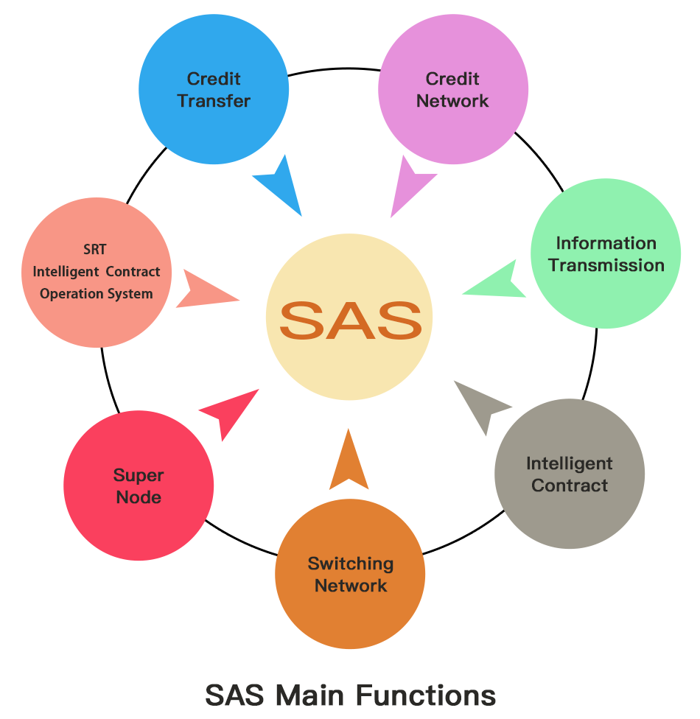and make the principle of technical inclusion more significant.

**Project Framework**

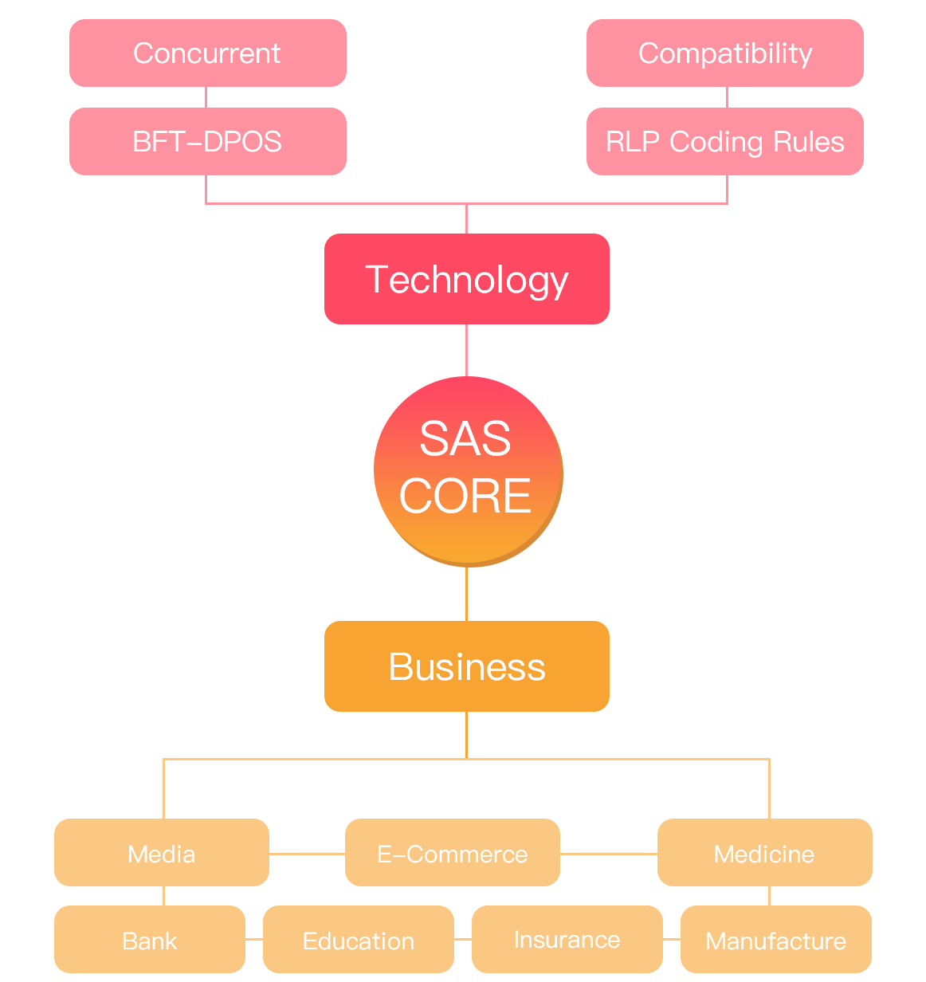

**Project Application Scenarios**



**Solutions for the manufacturing industry**

The problem of manufacturing industry lies in the completeness of information management.

The production and warehousing mechanism of modern industrial assembly line greatly enhances the production efficiency, but also greatly strengthens the requirements of product information management. Once there are product design defects or parts defects caused by equipment on the assembly line, it will cause a very serious blow to the enterprise. Under the traditional industry requirements, to avoid this situation, high-intensity pipeline management and warehousing management are needed to ensure the quality rate and stability of products.

SAS provides an effective solution to this problem. In SAS network, we can use the characteristics of blockchain traceability to track the production history, ensure the safety of the production process. From the source supply chain to warehousing, from warehousing to consumption chain, problems of every link can be quickly screened, and the loss and risk can be minimized.



**Solutions for the education industry**

Many problems in the education industry lie in opacity.

The problem is very serious especially in the Internet education industry. Various kinds of people who do not have the qualifications of teachers pretend to be senior teachers to deceive enterprises and students.

SAS can provide examination, confirmation and transmission of students’ transcripts, confirmation and record of teachers’ qualification certificates on the blockchain, and examination of the grant of educational support (scholarship), so that the public can see the authenticity and validity.



**Solutions for media and pan-entertainment industries**

The embezzlement of copyright of articles and pictures is normal for the media. However, it is difficult to trace the embezzlers, prove the ownership of copyright and claim for compensation, which is an important factor restricting the development of the media industry.

Copyright issues are also the focus for the pan-entertainment industry. In addition, fraud caused by opaque transactions and non-disclosure in the game industry is also common.

SAS provides a copyright traceability system management, which records copyright information through blockchains, links the copyright owned by the creator, traces the information of the copyright embezzlers, sends warnings and even claim information orientated according to the creator’s requirements, and guarantees the creator’s security. For game transactions, SAS will guarantee the completion of the transaction by means of multiple confirmations on the chain.



**Solutions for sales and e-commerce**

The key problem of sales industry and e-commerce is the security of supply chain.

In the traditional sales industry, such as supermarkets, specialty stores and so on, it is impossible to guarantee the security and stability of their supply chain in many cases, especially the agricultural products of supermarkets. Under the premise of huge transaction volume, it is almost impossible to trace supply chain security through traditional schemes.

The same problem is faced in the field of e-commerce. The key is the information gap.

SAS can significantly reduce counterfeit and inferior products, increase transparency and reduce information asymmetry through the form of decentralized blockchains, information up-link and multi-point openness. In addition, providers, consumers, senior sales professionals and even market regulators can inspect and supervise product problems seamlessly.



**Solutions for medical care and pharmaceuticals**

The key problem of medical care is the synchronization and authenticity of medical information records. Misdiagnosis or improper behavior of patients often lead to medical accidents.

Pharmaceutical industry has very high security requirements for supply chain management and production process. The management and effect of new drug testing is a very high-risk and strongly unstable category.

SAS Blockchain System can carry information with SAS Blockchain in the form of medical information up-link, serialize and trace the use of drugs, strictly track the clinical management of new drugs, and promote the privacy protection and authorization sharing of patients’ health records among medical institutions.



**Solutions for the insurance industry**

The problem with the insurance industry is the extreme asymmetry of information. The information of the insured can’t be fully known by the insurer. As a result, the anti-fraud investigation has greatly increased the cost of insurance companies, but also worsened the public’s impression of the insurance industry.

SAS system will construct a bridge between the insurer and the insured to examine and manage information, and establish claim automation and fraudulent claim interception through the form of information investigation.



**Solutions for banking and financial industry**

Banking and non-bank finance are the disaster areas of trust mechanism. The key lies in the systematic and human risks.

The risk of the system lies in the security of payment network, even PayPal has suffered payment system crash.

People’s risk lies in credit risk. The unreliability of personal credit and even corporate credit poses a serious threat to the security of funds. This phenomenon occurs mostly in the banking system, and the absence of management mechanism makes more unlawful elements available.

SAS Blockchain System will provide industrial solutions for banking and non-bank financial industry in the form of SaaS (Software as a service). It will also establish a decentralized financial network in the form of establishing, holding or acquiring international banks in the future.

On the SAS system, all fund storage, transaction information, fund liquidation, cross-border payment, loan management, fund formation and anti-money laundering review will be completely carried out and made public through a decentralized system.



**More**

The strong point of SAS is reflected in various solutions in the application of blockchain technology. In addition to the above application scenarios, there are more scenarios waiting for global users to participate in and develop.

**SRT Protocol**

SRT is an intelligent contract protocol developed based on the SAS system.

SAS is named a new generation of BFT-DPOS decentralized application platform, which supports Turing’s complete intelligent contract and SRT protocol. At the same time, it supports all the intelligent contracts of Ethereum, and it also supports the implementation of DAPP with high-performance consensus to build blockchain 5.0 era.

SRT protocol standard

As a new generation of token embodiment of Token Economy, SRT has the following standards:

**Method**

1. name

function name() constant returns (string name)

The name of Token with the type of returning string, such as SAS

2. symbol

function symbol() constant returns (string symbol)

The symbol of Token with the type of returning string is the abbreviation of Token, such as SAS.

3. decimals

function decimals() constant returns (uint8 decimals)

It supports a few decimal places behind the decimal point. If it is set as 3, it will support 0.001.

4. total Supply

function totalSupply() constant returns (uint256 total Supply)

The total number of Tokens issued can be obtained through this function. The total number of all Token certificates issued by the smart contract is fixed, so the the initial value must be set for totalSupply.

5. balanceOf

function balanceOf(address _owner) constant returns (uint256 balance)

Enter the address to get the number of Tokens.

6. transfer

function transfer(address _to, uint256 _value) returns (bool success)

Call the transfer function to transfer your own token to the _to address, and _value is the number of transfers.

7. approve

function approve(address _spender, uint256 _value) returns (bool success)

Approve the _spender account to transfer _value tokens from your own account. It can be transferred for multiple times.

8. transferFrom

function transferFrom(address _from, address _to, uint256 _value) returns (bool success)

It is used in conjunction with approve, while call the transferFrom function to transfer the token after approved.

9. allowance

function allowance(address _owner, address _spender) constant returns (uint256 remaining)

Returning _spender can also extract the number of tokens.

**Events**

1. Transfer

event Transfer(address indexed _from, address indexed _to, uint256 _value)

When the token is successfully transferred, Transfer event must be triggered.

2. Approval

event Approval(address indexed _owner, address indexed _spender, uint256 _value)

When the approve function is successfully called, the Approval event must be triggered.

**DAPP**

According to the definition given by Wikipedia, “decentralized application” is an application that many users run on decentralized networks with no trust protocols. They are designed to avoid any single point of failure and they usually have Token to reward users with computing power.

Compared with DAPP, traditional applications involve many problems. First, such application servers are hosted on hosted services, which use a centralized architecture and can cause a single point of failure in the case of malicious attacks. When we rely on centralized servers, data is more vulnerable to be attacked.

There is not any central service in DAPP to control and determine the errors or corrections of nodes, so consensus mechanism is used to solve this problem.

**The advantages of DAPP:**

1. DAPP has good fault tolerance because there is no single point of failure and they are allocated by default.

2. The domain or IP address of DAPP can hardly be shielded or eliminated, because DAPP is not accessed through a specific IP address or domain. Obviously, some intervention forces can track and shut down the nodes in the network through IP addresses, but if the scale of network is large, it is almost impossible to shut down the application, especially if the nodes are distributed in different countries.

3. Applications that users can trust, because no center can control or fake because of their own interests.

**Four application directions of DAPP:**

1. Financial information records

In financial institutions, DAPP provides transparency and accuracy of related data records on all financial information. This helps to reduce audit costs and improve financial reporting, as well as to achieve the unification of financial data.

2. Securities

DAPP can provide security for the system, and through DAPP the third party can be avoided.

3. Digital identity

DAPP allows a person to control and own his own digital identity containing data. It allows people to selectively disclose personal data that are used to count their customers to counterparties.

4. Insurance policy

Claims process may take more than a month to get paid. Obviously, it is not yet possible to get the convenience brought by the development of science and technology. The process still needs to be operated manually, which reduces the efficiency. But it can change the status quo by writing on DAPPS, so that the process is accurate and fast.

**Project Vision**

1. **The origin of the project vision**

There have been three revolutions in four hundred years of industrial history. For the first time, that is, the first industrial revolution – the Steam Technology Revolution, steam was used to crush tens of thousands of workers; for the second time, that is, the Power Technology Revolution, power was used to light up the fame and fortune fields of aristocracy struggle; for the third time, that is, Scientific and Technical Revolution, the Internet was used to extend the tentacles of consortia, and regarded as the tool to monitor user behavior and to sell user data, which spread all over the world.

Every breakthrough in the development of human technology is based on the improvement of efficiency, but at the same time it is accompanied by the extreme lack of security and fairness. Productivity does not necessarily determine the relationship of production, or more accurately, the one-sided development of productivity does not change the relationship of production.

"Man is the measure of all things" (The famous philosophical proposition of Protagoras, an ancient Greek wise man in the 5th century BC.), and it is very important to protect the safety and fairness of users.

In this background, Blockchain technology is born. It strives to complete those areas that do not draw enough attention, especially in the aspect of the trust and equality of users, and commits to greatly reduce the trust cost of users and achieve integration from fairness to efficiency through the trust mechanism.

However, there are some serious shortcomings in our current block chain technology. Just because of this, it can't fully integrate into modern society.

The first problem is the speed of transaction processing. For this speed, we introduce a quantifier, TPS (the number of transactions per second). Bitcoin's TPS is only around 10, and there is absolutely no way to challenge VISA's 1700TPS.

The second problem is the application scenario. Many of our technical flaws make the lack of this kind of application scenario quite serious, and further increase the user's use cost.

Only by solving these two problems can we solve the problems of the blockchain, human problems and come true the coexistence of efficiency and fairness.

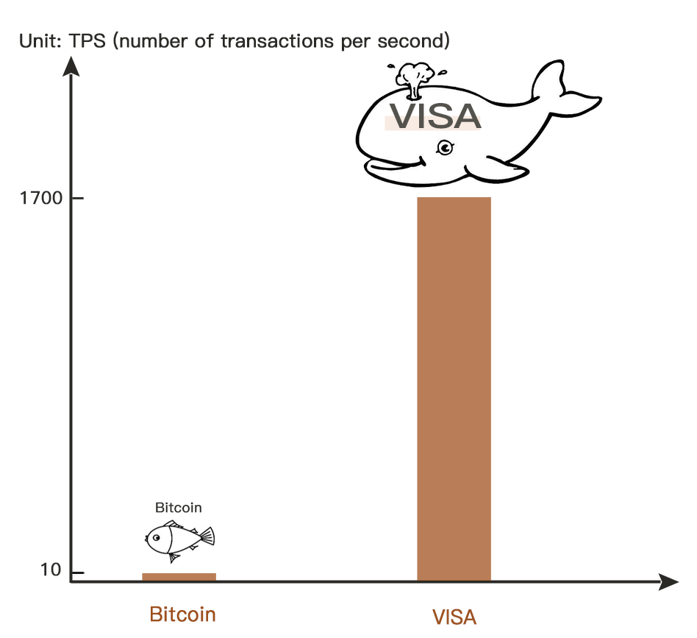

1. **Progress**

Today, the 10th anniversary of blockchain technology, the Super Smart Application System (abbreviated as: SAS) based on blockchain technology has been introduced.

SAS adopts the optimized DPOS consensus mechanism, which can achieve a million-level TPS with high transaction processing efficiency. At the same time, it is compatible with all smart contracts written in Solidity language including Ethereum, which is very convenient for users. The combination of the high-performance technology implementations and super compatibility smart contracts can meet all application requirements in the next 5 to 10 years.

1. **The innovation that comes with human pursuit**

In 1941, US President Franklin Roosevelt delivered a State of the Union address, discussing the "Four Freedoms" in the annals of history, which represents the core values of the United States, and enshrined in the United Nations Universal Declaration of Human Rights. This is also the core idea of SAS in the development process.

## Freedom of speech

SAS is a decentralized network space. Anonymous security guarantees that everyone can conceal communication in the decentralized community; and SAS grants users a greater degree of authority to express their opinions. In addition this, users can put forward opinions and suggestions to the community, and pass or reject them by voting. That is to say, SAS grants not only the freedom of speech, but also the power of speech.

## Freedom of religion

SAS respects the rights of users' beliefs. That means that SAS will not use any religious videos, graphics, and promotional texts in all documents, official meetings, and community presentations.

## Freedom from want

In the course of its development, SAS is actually a process of subverting the traditional distribution mechanism. We can re-establish a fair financial and market system so that workers are not exploited, consumers are not harmed, and corruption and bullying are invisible.

## Freedom from fear

SAS guarantees the security of user assets. That means that the asset network built on the blockchain will block the persecution of malignant technology to the greatest extent and build a security wall.

**Technology**

**BFT-DPOS Consensus Mechanism of SAS**

The SAS software architecture uses the best performance solution at present - BFT-DPOS (Byzantine Fault Tolerance - Deligated Proof of Stake, with Byzantine fault tolerant entrusted equity certificate). According to this algorithm, people who hold SAS on the whole network can select the producers of blocks through the voting system. Once elected, any node can participate in the production of blocks.

A block is generated every 3 seconds in the SAS. At any time, only one producer is authorized to generate blocks. If the block is not successfully released within a certain time, the block is skipped.

In the SAS framework, block generation is based on 21 blocks as a cycle, and every 30 cycles is an election cycle. And 21 block producers will be voted out. If the number of blockers is less than half in each campaign cycle, the system will kick the blocker out of the super node, which is designed to ensure the smooth operation of the SAS network.

Under normal circumstances, the DPOS blockchain does not experience any forks, because the block producers cooperate to produce blocks rather than compete. If there is a block fork, the consensus will automatically switch to the longest chain. The blockchain length with more producers will grow faster than the blockchain with fewer producers. In addition, no block producer should produce blocks on both blockchain forks at the same time. If a block producer is found to do this, he may be voted out.

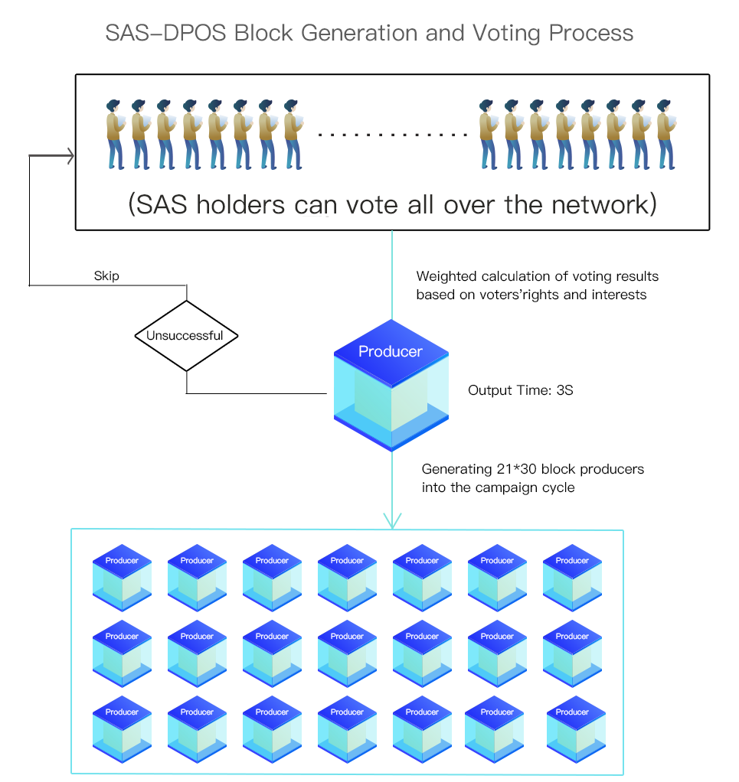

**Transaction Confirmation**

The blockchain maintained by the DPOS consensus algorithm is generally 100% online. That is to say, a transaction will be written to the blockchain after an average of 3 seconds, and the transaction will be known to all the block nodes. This means that it takes only 3 seconds, and a transaction can be considered 99.9% to be received by the blockchain.

There are some extreme cases where, for example, software bugs, Internet congestion or malicious blockers appear, where the blockchains may appear forked. To ensure that a transaction is irreversible, you can wait for 15 blocks to confirm. According to the configuration of the SAS software, it takes an average of 45 seconds to confirm the 15 blocks under normal conditions.

Within 9 seconds of the fork, the block node will find the possibility of this fork and warn the user. When a node observes a network, it discovers two consecutive block loss events, which means that the node is 95% likely to branch on the branch of the blockchain. After three consecutive blocks are lost, the node has a 99% probability of being on a forked blockchain. The SAS system can generate a predictive model that will use the missing information lost by the node, so that the recent participation rate, and other factors can quickly alert the user to what is wrong.

The response to this warning depends entirely on the nature of the business transaction, but the simplest response is to wait for 15/21 confirmation until the warning stops.

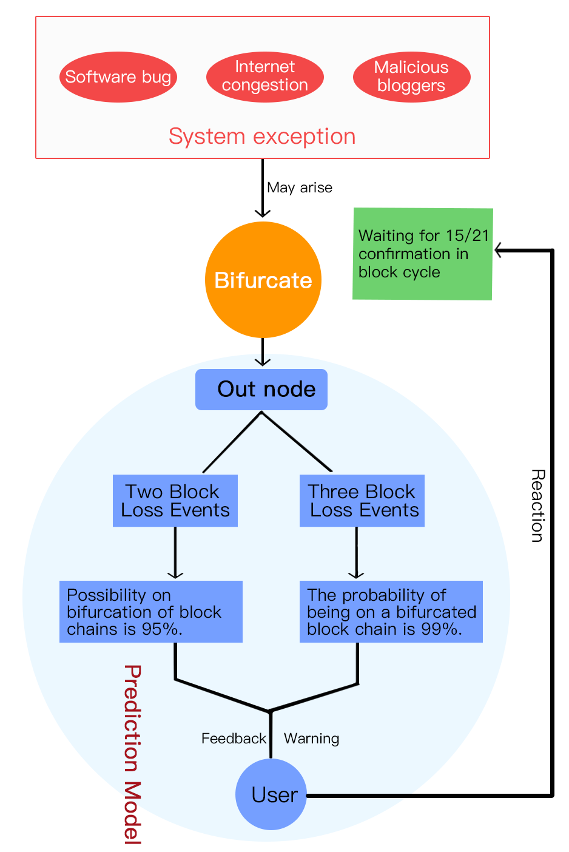

**Proof of Completion**

When using the proof of Merkel tree of the outer blockchain, there is a huge difference between knowing that all processed transactions are valid and knowing whether any transactions have been ignored. This is due to the fact that it is impossible to prove that all recent transactions are known, but it is possible to prove that there is no missing data between historical transactions. The SAS operating system achieves this by assigning a sequential identification number to each of the information arriving at the account, and the users can use these identifiers to prove that all messages addressed to this account have been processed and processed in sequence.

**Smart Contract System - SRT**

Based on the convenience, security and comprehensiveness of users, we have conducted a lot of research and repeated testing on the intelligent contract system of blockchain, and successfully launched the SAS-based intelligent contract system SRT.

The SRT is developed independently on the basis of SAS. And the developer can call the API interface of SAS to establish a smart contract based on the SAS main network and the contract will be published on the SAS blockchain browser.

SRT will develop and evolve on this basis, so that smart contracts can be endowed with more functions, and through the smart contract, the blockchain can enter the needs of social production and life more.

SAS is equivalent to the ownership of network resources, and users can only use the corresponding proportion of network resources. Therefore, DOS attackers can only use the bandwidth resources of their SAS corresponding proportions, forming a natural institutional barrier, so that DOS attacks can only appear on an application, but these attacks will never destroy the entire network operation. In view of this, the safety of the entire infrastructure chain has been improved from the design by SAS.

In order to achieve better compatibility, cross-chain interaction and virtual machine independent architecture mechanism are designed in SAS. For example, an SVM virtual machine is built into the SAS system to support existing Ethereum contracts. All smart contract applications on the existing Ethereum platform can be run on SAS with only a little configuration.

For developers, it is not easy to develop DAPP on other public chains at present. And it is necessary for them to write a lot of basic modules to achieve the goal. The design goal of SAS is to become the underlying operating system of the blockchain, and it has provided various underlying development modules for developers. In short, all kinds of basic functions SAS have been designed for developers. So for developers, they only need to know how to use these basic tools to complete their own development. And the way will greatly reduce the threshold of developers. Apart from the advantage, the way possesses the merit that the fast processing speed and low commission of the SAS platform, which will attract more developers, help SAS platform emerge a large number of commercial applications, and quickly form a platform ecosystem.

From the above analysis, it is not difficult to conclude that from the perspective of architecture design, SAS is very promising to become a super low-level public chain that is capable of supporting large-scale commercial applications.

**Development**

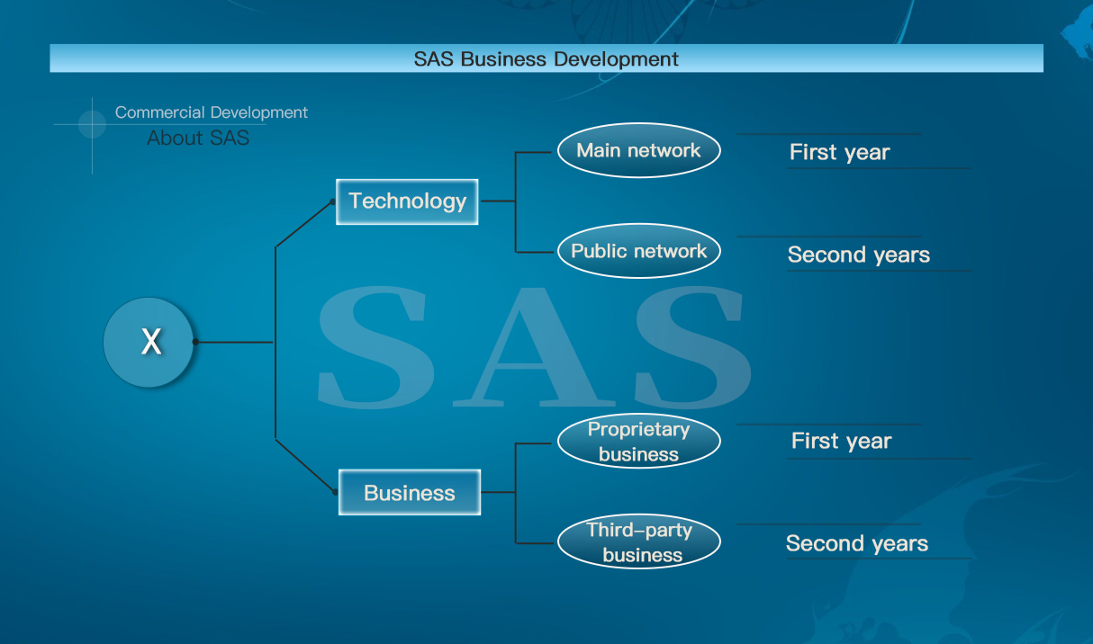

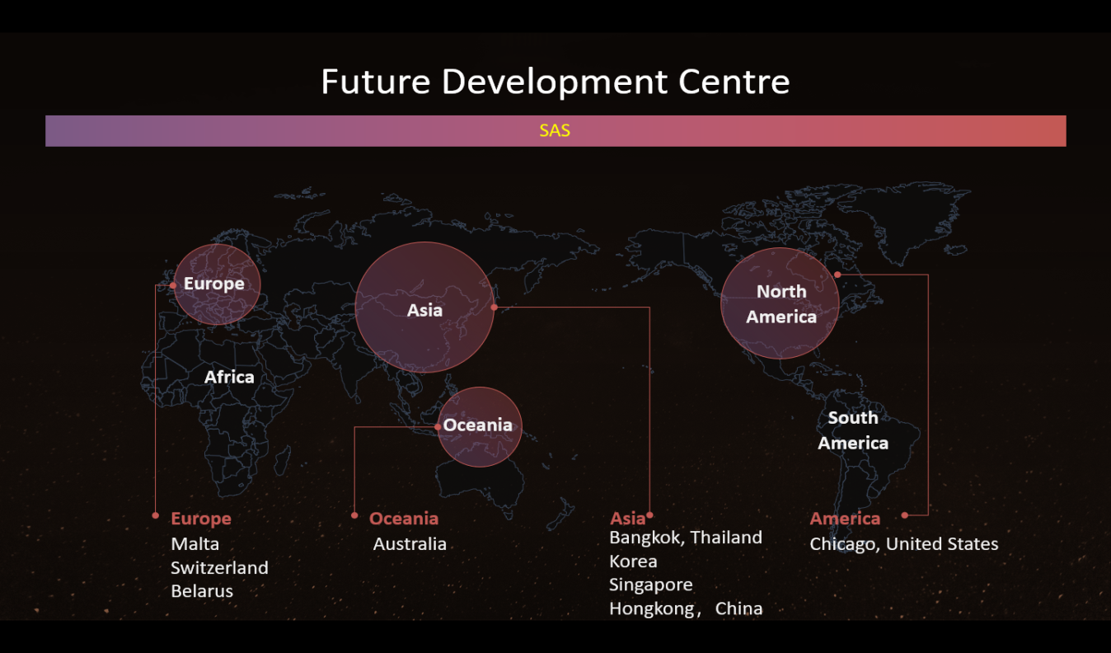

**Issuance and Usage**

**Issuance of Allocation Plan**

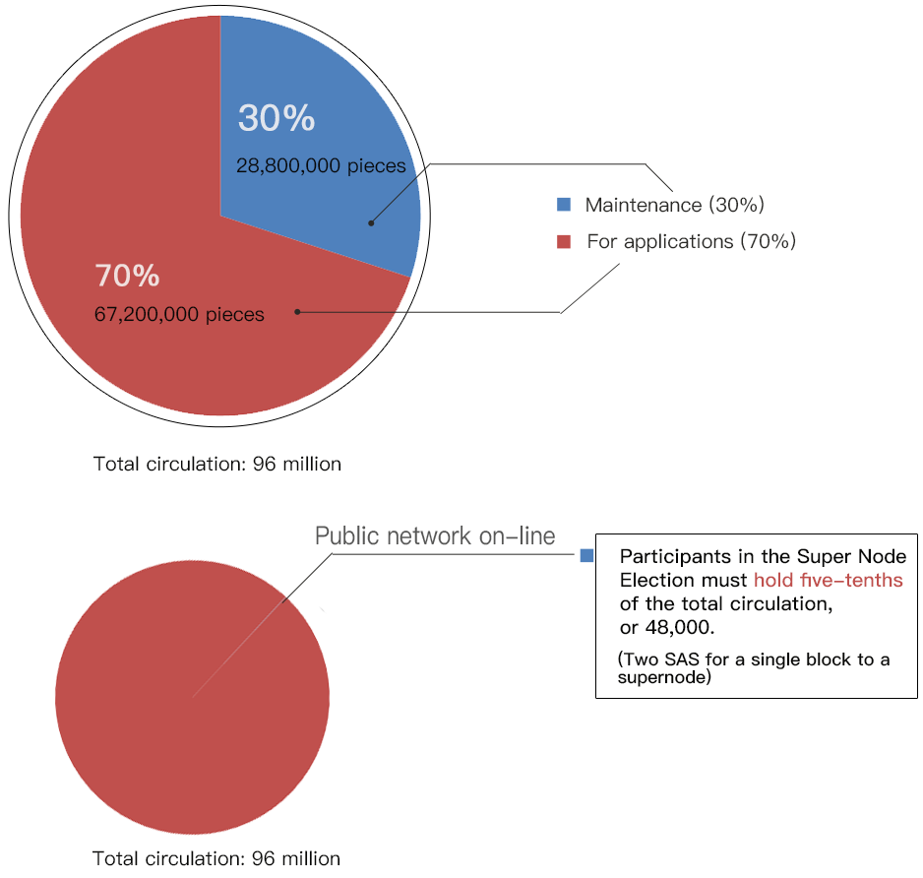The total circulation of SAS is 96 million, of which 30% is for the maintenance of Super Node and 70% for platform applications (such as the costs of metering and constraining the execution resource). After the public network goes online, 2 SAS rewards will be awarded to the Super Node as a single block. After the public network goes online, candidates who participate in the Super Node election must hold five in ten thousand of the total circulation, that is, 48,000 SAS.

**Usage**

1. SAS can be used in the digital world without geographical restrictions. It does not belong to any country or financial institution, and can be exchanged anywhere in the world to purchase all opened products and services in the SAS platform.

2. SAS is a transmission system mechanism for the trusted third party that is used as the buyer and purchaser to provide the transmission reputation intermediary and ensures the integrity and security of digital asset transaction as a means of transmission to promote safe online trading in the usage platform based on SAS.

3. SAS can be used for commodity exchange and value swapping between SAS participants without exposing private information. Since the exchange between nodes follows a fixed algorithm, the data interaction is untrusted (the program rules in SAS will independently judge whether the activity is valid or not). Therefore, the counterparty does not need to let the other party trust him by making identity in public, which is very helpful for credit accumulation.

**Disclaimer**

**What is SAS?**

SAS is a kind of software product with cryptographic element that is sold as a utility tool of the SAS platform.

SAS only has its functional utility in the SAS platform. In addition, its generation is constrained by the internal economic development needs and product design in the ecosystem, which will establish a transparent and fair relationship in the SAS community.

The holder of SAS only uses it for specific purposes. The number of such purposes may increase over time, including but not limited to rely on adding the new services and functions that can be used to redeem SAS.

SAS is specifically designed to handle the decentralized value delivery based on blockchain software system.

**Usage of SAS**

**1. SAS carries the main functions of the SAS platform.**

Only the SAS holders can use all the functions of the SAS platform. We plan to place SAS on the overseas crypto aset exchange to provide the opportunity(for the residents of a country/region that do not violate local laws to purchase in SAS platform) to purchase SAS in public. Users seeking to enter the SAS platform have to purchase SAS on such exchanges. In contrast, the holder can sell SAS on the exchange if he wants to exit the ecosystem.

However, legislation on the circulation of securities in certain countries (such as the United States of America, the People’s Republic of China and the Republic of Korea, etc.) may prohibit to sell SAS to the residents. When purchasing SAS, the purchaser should understand the limitations of subsequent sales of SAS, so the instructions of SAS Project Foundation and the Exchange must be followed when reselling SAS to other users.

**2. The expression means of the opinions from community.**

The platform will provide SAS holders with the opportunity to discuss the overall development and key issues of the various businesses in the SAS system through a decentralized community voting (DCV) mechanism, including the business expansion of the SAS platform, the positioning of SAS attributes (the positioning of goods, securities and values), and the problem that the further legal compliance of SAS is related to the sustainable and effective development of the SAS platform.

These decisions expressed through the DCV mechanism will be regarded as the consulting guidance of SAS platform management. the management teams and executives of SAS will consistently incorporate SAS community voting results into their consideration. However, we do not guarantee that all management requests will be accepted unconditionally.

**Method of settlement**

SAS will be used as the method of settlement for transactions to be conducted in the SAS platform. In particular, SAS holders can use SAS to purchase services and products offered in the SAS platform.

**What can't SAS do?**

SAS cannot be used as a security in any jurisdiction.

This whitepaper shall not constitute a prospectus or any type of offer document, and is not intended to constitute a securities offer or investment solicitation. In addition, it shall not involve an initial public offering or a stock offering or financing in any way, as well as shall not involve the sales of securities in any jurisdiction in any way. SAS is not intended to promote, present the sales, purchase, sell or trade in any jurisdiction that is prohibited by applicable law or that requires further registration in any relevant government agency.

**SAS is not a loan to the company**

It should be noted that SAS is neither a debt instrument or bond of any nature nor any other form of loan prepaid to the company. SAS obtained through SAS or through other means shall not entitle the SAS holder to have any claim on the financial or any other assets of the company.

In addition, SAS shall not grant the right to participate in the company or its assets.

SAS shall not provide the SAS holders with any ownership or other benefits of the company. The acquisition of SAS shall not mean to exchange for any forms of shares or assets of the company(including intellectual property right). SAS holders are not entitled to any guaranteed form of dividends, income distribution and voting rights.

**SAS is non-refundable**

The company will not provide SAS holders with any refund related to SAS for any reason, and SAS holders will not receive money or other compensation in lieu of a refund. Moreover, there is not and will not be any commitment to the future performance or value of SAS, including a commitment to intrinsic value, a commitment to ongoing operations, and an assurance that SAS has any specific value.

**Company Personnel**

|  |  |
| --- | --- |
| Stephen DavisServed as a program developerRegion: Florida, USASkills: java, android/iOS development and responsive designObtained bachelor’s degree in Communication from Florida State University and master’s degree in International Finance.From 2011 to 2013, served as an ups CEO consultant.From 2015 to 2016, served as the supervisor of the technical department of the Florida State Government.From 2016 to 2017, served as the supervisor of the technical department of HSBC Bank (UK). |  |
| Selman Tunagur  Region: Istanbul, Turkey  Skills: java and development of android and iOS.  Obtained MBA in Social Science from University of Istanbul;  Served as the former Chief Engineer of IBM. |  |
| M Shoaib Khokhar Region: New York, USA  Skills: marketing and market management  From 2014 to 2016, served as CMO of the famous American land agent Admri.  From 2016 to 2018, served as the manager of marketing department of Apple. |  |
| Juan Negrin  Region: Madrid, Spain  Skills: php and mysql  From 2017 to 2018, served as the manager of of technical department of Tesla |  |
| Deborah Romero  Region: Hong Kong  Obtained EMBA from University of Hong Kong  Skills: user management and corporate strategy  From 2016 to 2018, served as the manager of of user management department of Google.  At the beginning of 2019, joined SAS BLOCK TECH LTD. |  |

|  |  |
| --- | --- |
| Dare Shonubi  Region: Lagos, Nigeria  Skills: digital marketing and Internet marketing  From 2017 to 2018, served as the co-founder of c-pro.  From 2018 to 2019, served as the manager of the marketing department of Coinbase. |  |
| Carlos Daniel  Skills: trading, fund management and corporate finance  From 2016 to 2017, served as the senior trader in trade.com.  From 2017 to 1919, served as the chief dealer of UBS. |  |

Compliance Program

Based on the further market demand and compliance management requirement for SAS, SAS Foundation will be registered through Form D in the form of Exempt Offerings (exempted securities issuance) according to financial financing requirements of Small Business of SEC on the basis of the SAS UK special subsidiary (a special financial company with the nature of foundation).

For the overseas compliance work of SAS, the specific time and rhythm will be determined according to the needs of market development and legal compliance. Moreover, there may be significant differences with the plan in terms of specific implementation and details. In this regard, the SAS Project Foundation shall not guarantee and confirm the specific time of the specific compliance process, but shall publish SAS participants in a timely, effective, open and compliant manner for the compliance matters.

**Compliance subject: SAS Block Tech Ltd.**

**Category of compliance subject: Limited**

**Place of registration: United Kingdom of Great Britain and Northern Ireland**

**Place of tax payment: United Kingdom of Great Britain and Northern Ireland**

**Anti-money laundering management: JPMorgan Chase (British)**

**Fund account management: JPMorgan Chase**

**Financing management: JPMorgan Chase, Merrill Lynch (Bank of America)**

Statement: This compliance program will comply with the relevant provisions of *Jumpstart Our Business Startups Act of 2012* (JOBS Act) and will disclose the company information to consumers subject to the financial requirements of Bank of America.

After completing the compliance process and compliance, SAS will abide by the provisions of AML (Anti-Money laundering) system and establish an account anomaly monitoring system and account transaction monitoring system while maintaining technical independence without damaging the overall decentralized environment, so as to complete the KYC requirements of financial institutions and combat international money laundering.

The compliance of SAS in the United States is only limited to the countries or regions under the jurisdiction or common jurisdiction of the US Securities and Exchange Commission (SEC) in the United States and Canada, etc., where SAS will acquire the asset functions of asset and securities. Furthermore, SAS participants shall comply with the local laws and regulations to determine whether they are eligible to purchase or trade SAS in other countries or regions that are not under the jurisdiction or common jurisdiction of SEC.

Compliance is a bumpy process, in which changes and adjustments may be required. The compliance program of SAS reflects the current development path and understanding of government regulation. In short, we will continue to understand the market, the professionals in the industry, and the partners and users, as well as adjust the process and sequence accordingly, thus ensuring to further improve our products and services based on legal feasibility.